ADVERT
Consultancy Opportunity at Ripon Museum Trust
Technical Project Manager for the Fairer Futures Project
£8,333 plus VAT

Ripon Museum Trust is seeking an experienced Project Manager to steer the Trust through the Development Phase of its Fairer Futures Project funded by the National Lottery Heritage Fund.

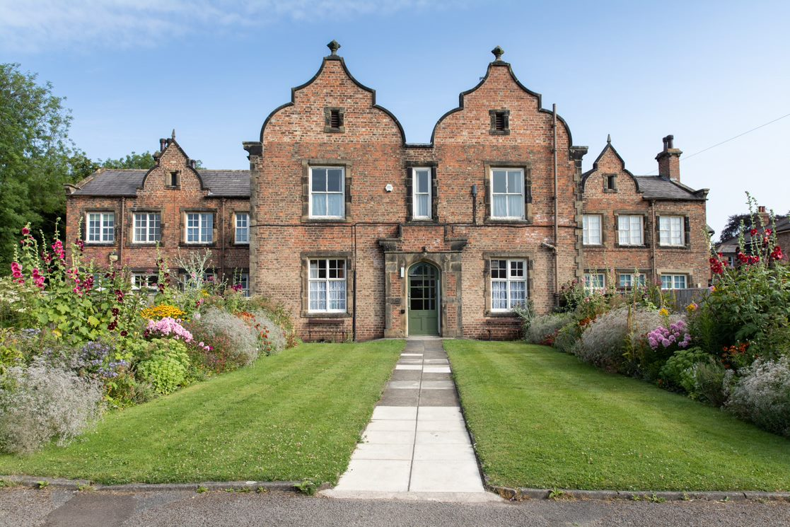

About the project
Our ‘Fairer Futures’ Project is worth £2.25M and is a substantial first step to delivering our ‘Master Plan’ for the Trust’s future. Delivery of this Project will make significant strides towards achieving our Vision, transform the visitor experience and our engagement work with communities. It will create inclusive new spaces in the Workhouse Museum, open up previously unseen rooms and make our heritage accessible to a wider more diverse audience across all three museums. The Project will use joined up stories of the people who lived, worked and suffered at our three sites. We will make better use of our outdoor spaces and of digital techniques for more immersive engagement. The Project will secure our future and lower our carbon footprint through environmentally sustainable building improvements. The idea for our Project was born out of unease with growing social inequalities which have been exacerbated by the pandemic. A powerful new Vision for the use of our heritage emerged; to use it to inspire people to seek a fairer society. Over the last 3 years we have continued to develop these ideas and we have consulted widely. Our Project has six key strands:
Conservation of key areas of the Workhouse i.e. Main Block (recently acquired with a Heritage Lottery Fund grant). Conservation work will provide us with new spaces for activities, interpretation and learning. A lift will give access to the former dormitories which will be restored. We will prioritise eco-friendly design; a new roof, an air source heating system and improved insulation will all reduce our carbon footprint and help us become more resilient. Access to and conservation of these areas will ensure preservation of the stories and heritage for the future. New interpretative techniques will connect stories and visitor experiences across all three museums. With communities we will tell multi-layered stories of those who lived and worked here, bringing the story up to date. We will create a better-quality visitor experience, use digital and other interpretation for outdoor spaces at the Workhouse, improved internal spaces for learning, volunteering and other programming. Community engagement and co-production will build on our work with people whose voices are often invisible in history. There will be exciting opportunities for new activities at all our museums engaging new people and communities and for placemaking. These build on our work as a NPO and the unique projects we have already delivered.
Our work to improve Wellbeing will be built into our activities and reflects our ambition to be become a place that demonstrably improves people’s wellbeing. Volunteering is at the heart of what we do, and we will expand and build on this work. The value of our work on placemaking will increase by generating community wellbeing. We’ll build on successful partnerships to develop activities to better explain our heritage. The Project will feed into master planning for the regeneration of Ripon’s economy and bringing a wider sense of history and place.
About the role
Ripon Museum Trust (RMT) seeks to appoint a Technical Project Manager for the duration of the project through to 2026 to advise and assist the staff and Trustees. The consultant will be expected to oversee recruitment of key consultants, compliance, cost control, programme and payment claims during the Development Phase and to work in partnership with the RMT staff, trustee and volunteer teams to provide relevant reports to the National Lottery Heritage Fund. The Technical Project Manager will oversee the delivery of a high-quality project on time and within budget. All plans must be designed and delivered within the overall capital and revenue budget set for Fairer Futures project. There will be a break clause between the Development and Delivery phases of our Fairer Futures project. The Technical Project Manager will deliver the following:

- Prepare and manage the programme for the capital works and activities during both phases using MS Project or similar software.
- Oversee the work of all the members of the Project Team.
- Provide the necessary compliance data to enable successful and timely grant claim submissions
- Manage and report risk
- Liaise with the Director to ensure that technical compliance and quality of work go hand-in-hand.
- Ensure all tasks are completed according to the overall deadlines for the Mid-term Review and Delivery phase submission

A full Brief is available for those preparing a tender; Contact helen.thornton@riponmuseums.co.uk OR visit www.riponmuseums.co.uk/

How to tender

All tenders must be against the full Brief. Tenders should include
- A clear description of your proven track record of, and approach to, managing this kind of heritage and conservation project to quality standards, time and budget – list out 3 similar projects in terms of value and type you have led within the last 3 years and the role your consultancy played within those projects
- Which IT packages you have experience using and at what level for project management, collaboration, and electronic communication
- Recent examples of your experience and approach to managing budgets and project budget reporting
- Recent examples of your experience of and approach to procurement – list out procurement projects undertaken, and the consultancy role played within those projects.
- Recent examples of experience, awareness and approach working within the independent museum sector
- Your approach to delivering our Programme including key milestones
- Provide evidence of Insurances required – Professional Indemnity of £2m, Public Liability of £5m, Employers’ Liability £5 million
- Proposed fee structure with a breakdown of day rates. Travel time for site visits should be clearly set out and are included in the total fee.
- State your availability for interview as per dates in Brief
- CVs (4 pages each) for key team members including membership of relevant professional bodies and adherence to professional standards
- Contact details for at least two referees
- Maximum Tender page length 10 pages.
- Tenders must be signed by CEO, business owner or equivalent senior representative of the Consultancy.

Deadline for tenders

5pm 20th July 2022

Tenders should be sent via email to:
Helen Thornton, Director, Ripon Museum Trust. helen.thornton@riponmuseums.co.uk

All procurement is done according to National Lottery Heritage Fund Guidelines. Ripon Museum Trust is an equal opportunity employer and we commission work fairly and transparently. We welcome applications and tenders from all suitably qualified persons regardless of their race, sex, disability, religion/belief, sexual orientation, gender orientation or age. Selection Criteria for this consultancy is described in the full Brief.

