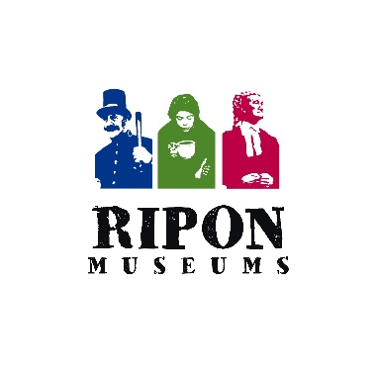

**Ripon Museum Trust**

**Annual General Meeting**

**DRAFT MINUTES**

**Tuesday 5th October 2021 7pm – 9pm**

**In person and Via Zoom (Z)**

**Present**: Richard Taylor, Mandy Whitehead (Z), David Thelwall, Christopher Hughes, Martin Webber, Alexa Vernon, Mary-Ann Irbins (Z), Virginia Arrowsmith (Z), Lindy Webb, Christine Orsler (Z), Helen Hattan (Z), Alison Brayshaw (Z), Sally Gibbins (Z), Moira Smith (Z), Tony Hirst, Mick Stanley, Dot Bowman, Robert Ling, Dave Rushton, Sonja Nowicki, Judy Jones, Pat Wilson, Colin and Jen Smith, Liz Barron (Z), Mandy Wilcock (Z), Carrie Philip, Lily Kellett, Jess Hesketh, Laura Allan, Helen Thornton.

Cal O’Connell was present as Digital Producer to support the Zoom attendance.

1. **Welcome and apologies.** Richard Taylor, Chair welcomed everyone to the 2020 AGM

**Apologies for absence** had been received from David Rhodes, David Ault, Lyn Bidgood, Pat Cunnings, Tina Gilchrist, Lizzy Tyler, Liz Mason, Roy and Drene Brooks, Mr and Mrs Beers

1. **Minutes of the AGM held on 115th October 2020**. These were approved as a correct record.
2. **Chairman’s Report**. Richard Taylor, Chair gave a short power point presentation and report. *He highlighted that the 2020 Annual Report and Accounts required by Companies House and the Charity Commission would be available to everyone shortly on our website****.***  *The Chair’s report covered the last 12 months in brief but also made reference the extraordinary support and input we had had from volunteers and staff through the Covid-19 pandemic. He talked about events and the regular Volunteer Update and thanked those members of staff concerned with delivering these. He concluded by thanking the whole team and the Director for getting RMT through an unprecedented year.*
3. **Director’s Report.** Helen Thornton, Director gave a short power point presentation and report about how Covid-19 had impacted RMT, how the Values of the Trust – Fairness, Ambition, Community, Learning and especially Teamwork had kept the organisation going and had contributed to the successes of re-opening. Reasons to be cautiously optimistic about 2022 as we pulled out of the pandemic and moved on to the next ACE portfolio and our Big Project.
4. **Treasurer’s Report.** David Thelwall, Treasurer gave a short powerpoint presentation *on the formal and trading accounts for 2020 (see Chairman’s report on availability of these shortly). A surplus of £14K was made on our trading account in 2019. He went on describe the projections for 2022. He thanked everyone involved with budget management during this difficult time. In particular he noted the passion and dedication of all involved, the clarity of our financial systems with special reference to accessing Emergency Funds and the maximising of Admissions under challenging conditions.*
5. **Appointment of independent financial examiners.** The continued engagement of HPH Chartered Accountants of Harrogate was approved.
6. **Election of Board.** Helen Thornton, Director took the chair for this item. According to our constitution we are required to have 3 (one third) of the Board step down each year according to their length of service since last appointment. Two trustees are stepping down but offering themselves for re-election – these are David Thelwall and Lizzy Tyler. Both Trustees were duly re-elected. Chris Hughes was stepping down from being a Trustee. Nominations had been sought to replace Chris. One nomination had been received, proposed by Martin Webber and seconded by Richard Taylor. Robert Ling was duly elected.

The meeting approved these re-elections.

1. **Chairman’s Forum.**

Tony Hirst spoke to the meeting about the popularity of the Ripon Ghost Walks and the success they had had since being able to walk again post-pandemic.

Moira Smith offered her thanks to everyone who had worked to keep Ripon Museum Trust going through the last 18 months.

Dave Rushton expressed concern about the condition of the Roof. Helen Thornton, Director in response described the efforts currently being made to repair the leaks and outlined the medium term strategy to get a large grant to replace the roof. She assured the meeting that all was being done and funds had been earmarked for this issue in the interim.

There was a short refreshment break

1. **Talk by new Community Curator, Laura Allan**.

Laura outlined her experiences working in museums – including in New Zealand – which had relevance to her new role including prison and police museums, using collections for engagement and working with volunteers.

The Chair thanked her on behalf of the meeting.

The meeting closed at 8:45pm.