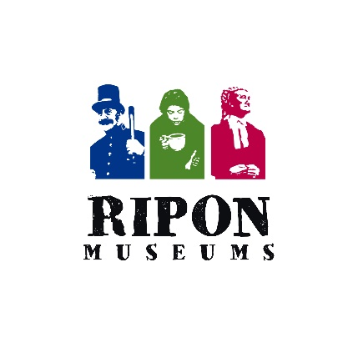
WE ARE LOOKING FOR A

Communications Lead, Ripon Museums

- Do you love telling stories that spark curiosity and make people stop scrolling?

- Are you a creative communicator with a flair for photography, video and words — someone who can craft engaging press releases, social media posts and content that truly connects?

- Do you believe museums can be powerful forces for social change, and want to play a part in building a fairer society?

- Are you confident working with a wide range of people — from national funders like Arts Council England to regional partners, local communities and a passionate team of 150 volunteers?

If this sounds like you, we’d love to hear from you.

Since 1982 Ripon Museum Trust has run three museums in the heart of the City of Ripon – the Workhouse Museum & Garden, the Prison & Police Museum and the Courthouse Museum. Together, they tell powerful human stories that explore justice, compassion and social responsibility.

We are looking to recruit a dynamic and creative Communications Lead to help put Ripon Museums firmly on the map. In this role, you’ll lead our communications across all marketing channels, shaping how we share our stories, values and ambitions with existing and new audiences.

Our vision is bold and clear - ‘To use our heritage assets to inspire others to seek a fairer society’ and we need the right person to help us to achieve this. We may be small, but we have ambitions to be mighty!

Arts Council England (ACE) and The National Lottery Heritage Fund (NLHF) recognise our potential and consider us worth investing in, and the next couple of years promise to be the most exciting in the museum’s development including the delivery of our ambitious £3.3m Inspiration For A Fairer Future project.

This role will be challenging at times, but it’s also deeply rewarding. Ripon Museum Trust is a close-knit, values-driven organisation, built on fairness, ambition, teamwork, community and learning. If you’re looking for meaningful work with purpose — and a genuinely supportive team — we’d love you to join us.

Work base: Ripon Workhouse Museum
Salary: £25,500 FTE (pro rata £15,506)
Contract: Permanent
Hours of work: Part-time – 22.5 hours per week
Work/life balance is incredibly important to us and we are incredibly flexible with working patterns. Some evening and weekend work will be required.
Holidays: 148.5 hrs of annual leave including bank holidays per annum plus your birthday off too (because no one should work on their birthday!)
Responsible to: Director of Museums

See the role description for further details about the position:
http://riponmuseums.co.uk/support/opportunities/

Closing date for applications: midnight Sunday 1st March 2026.

If you are interested in this position, please complete the application form on our website http://riponmuseums.co.uk/support/opportunities/ showing how you meet the criteria for the position.

Please send the completed application form to liz.ashworth@riponmuseums.co.uk Please do not send a CV – it will not be used for shortlisting.

For informal discussion about this post please contact Liz Ashworth, Business Support Coordinator in the first instance on liz.ashworth@riponmuseums.co.uk

